ProjectBox Database Design
ER Diagram

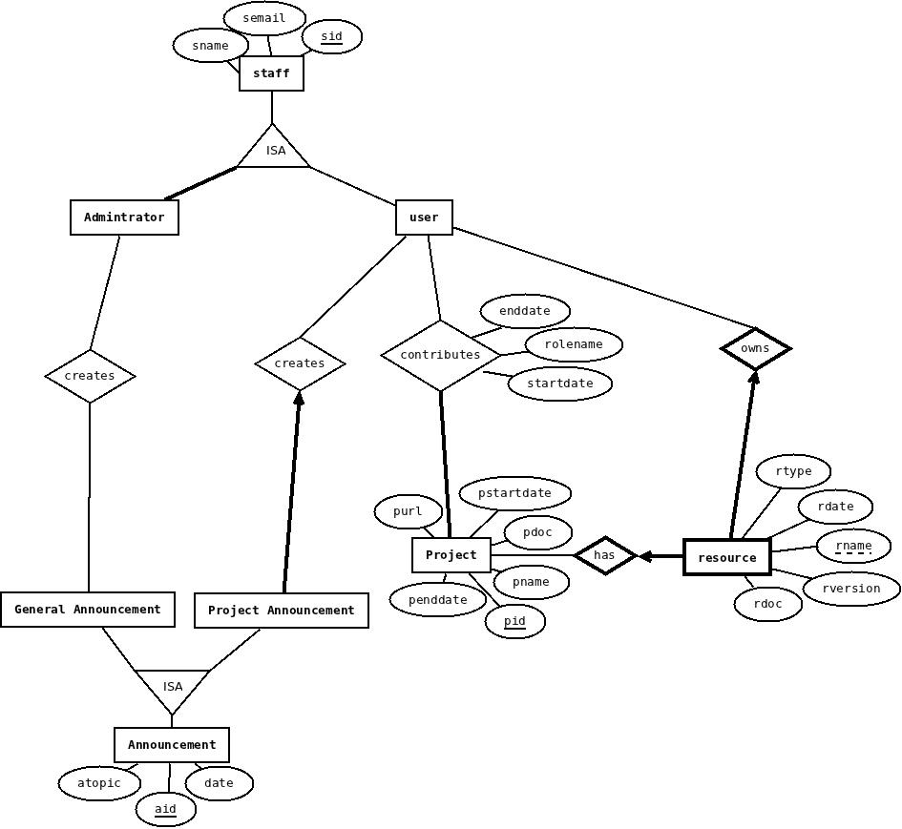

Primary tables

- Staff(sid, sname, semail, stype)

Represents: entity sets administrators and users of the projects
Primary key: (sid)
Constraints: staff id should be unique

- UserContribution (sid, pid, rolename, startdate, enddate)

Represents: entity sets Staff, Project and relationship set Contribution
Primary key: (sid, pid)
Foreign key: (sid) references Staff, (pid) references Project
Constraints: staff id and project id are unique, role name is not null

- Project(pid , pstartdate, penddate, pname, pdoc, purl, pemail)

Represents: entity set Project
Primary key: (pid)
Constraints: project id is unique

- Resource(pid, sid, rname, rversion, rdoc, rtype, rdate, rname)

Represents: entity sets Resouce and Staff and relationship set has and owns
Primary key: (pid, sid, rname)
Foreign key: (sid) references Staff, (pid) references Project
Constraints: resourcename, staff id and project id are unique, resource name is not null

- Announcement(aid, sid, atopic, adate, atype)

Represents: entity sets GeneralAnnouncement, ProjectAnnuouncement and relationship set creates
Primary key: (aid)
Foreign key: (sid) references Staff
Constraints: announcement id and staff id are unique

Tales and there dependency

Base Tables
- Staff(staffrid, sname, semail, usertype)
- Project(pid , startdate, enddate, pname, pdoc, purl, pemail)

Dependent tables
Hierarchical order of table, need to be entered
Staff table
Announcement table
Project table
UserContributionnn
Resource table

Functional Dependencies

The following is a list of FD's for each table:

- Staff (sid, sname, semail, stype)

- sid→ sname, semail, stype

- UserContribution (sid, pid, rolename, startdate, enddate)

- sid, pid→ rolename, startdate, enddate

- Project (pid , startdate, enddate, pname, pdoc, purl, pemail)

- pid → startdate, enddate, pname, pdoc,purl, pemail

4. Resource (pid, sid, resourcename, rversion, rdoc, rtype, rdate, rname)

- pid, sid, resourcename → version, doc, rtype, rdate, rname

5 Announcement (aid, sid, topic, date, atype)

- aid, sid→ topic, date
- sid→ atype

Normalazation

All the tables are in BCNF.

